Interior design is both a science and an art, focusing on creating visually appealing and functional environments. By applying fundamental principles, designers can craft interiors that are not only beautiful but also harmonious, balanced and practical. This article explores the principles of contrast, dominance, rhythm, focal point, scale, proportion, and balance, providing techniques for their application in interior design projects.

# Balance

Balance refers to the even distribution of visual weight in a room, providing a sense of stability and calm.

Application in an Interior Design Project:

* **Symmetrical Balance:** This traditional approach uses identical objects on either side of a central point (Fig 1). For example, placing matching lamps on both sides of a bed or sofa creates a mirror image that feels orderly and serene.
* **Asymmetrical Balance**: A more dynamic approach where different objects of similar weight create a balanced feel (Fig 3). For instance, pairing a large couch with a couple of smaller chairs and a floor lamp can achieve a visually interesting balance.
* **Radial Balance**: Design elements radiate from a central focal point, like a round dining table surrounded by chairs (Fig 2), creating a cohesive and visually engaging layout.

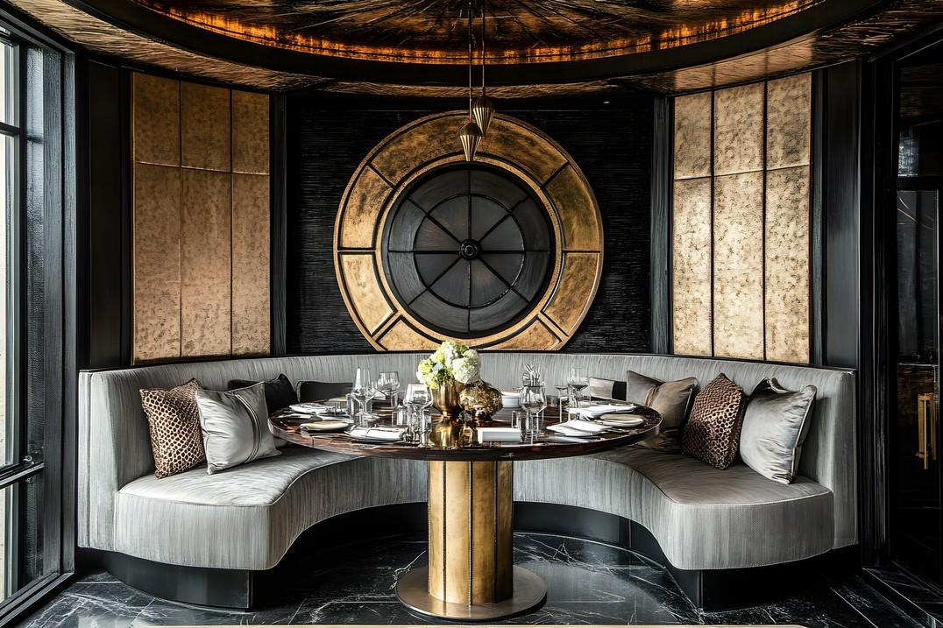

Fig. 1.Pixabay (2024), Radial Balance https://pixabay.com/illustrations/table-dining-dinner-restaurant-8974555/

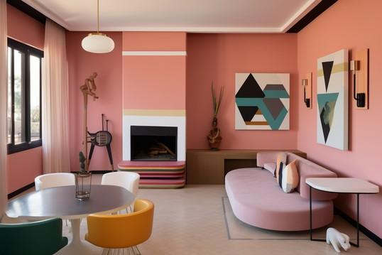

Fig. 2. Pixabay (n.d.), Asymmetrical Balance

# Rhythm

Rhythm in interior design involves creating patterns and contrasts with the use of repetitive shapes or elements, in order to guide the eye through the space, establishing a sense of movement and energy.

Application in an Interior Design Project:

* **Repetition**: Use the same elements at regular intervals. For example, aligning a series of pendant lights along a kitchen island or repeating a particular pattern in fabrics and wallpapers throughout the room.
* **Alternation**: Incorporate elements in an alternating pattern, such as using light and dark- coloured cushions on a sofa or alternating plants and books on a shelf.
* **Progression**: Gradually varying the size or intensity of elements, such as arranging decorative items in ascending order of height on a console table.

Fig. 3. Pexels (n.d.), Rhythm in Architectural features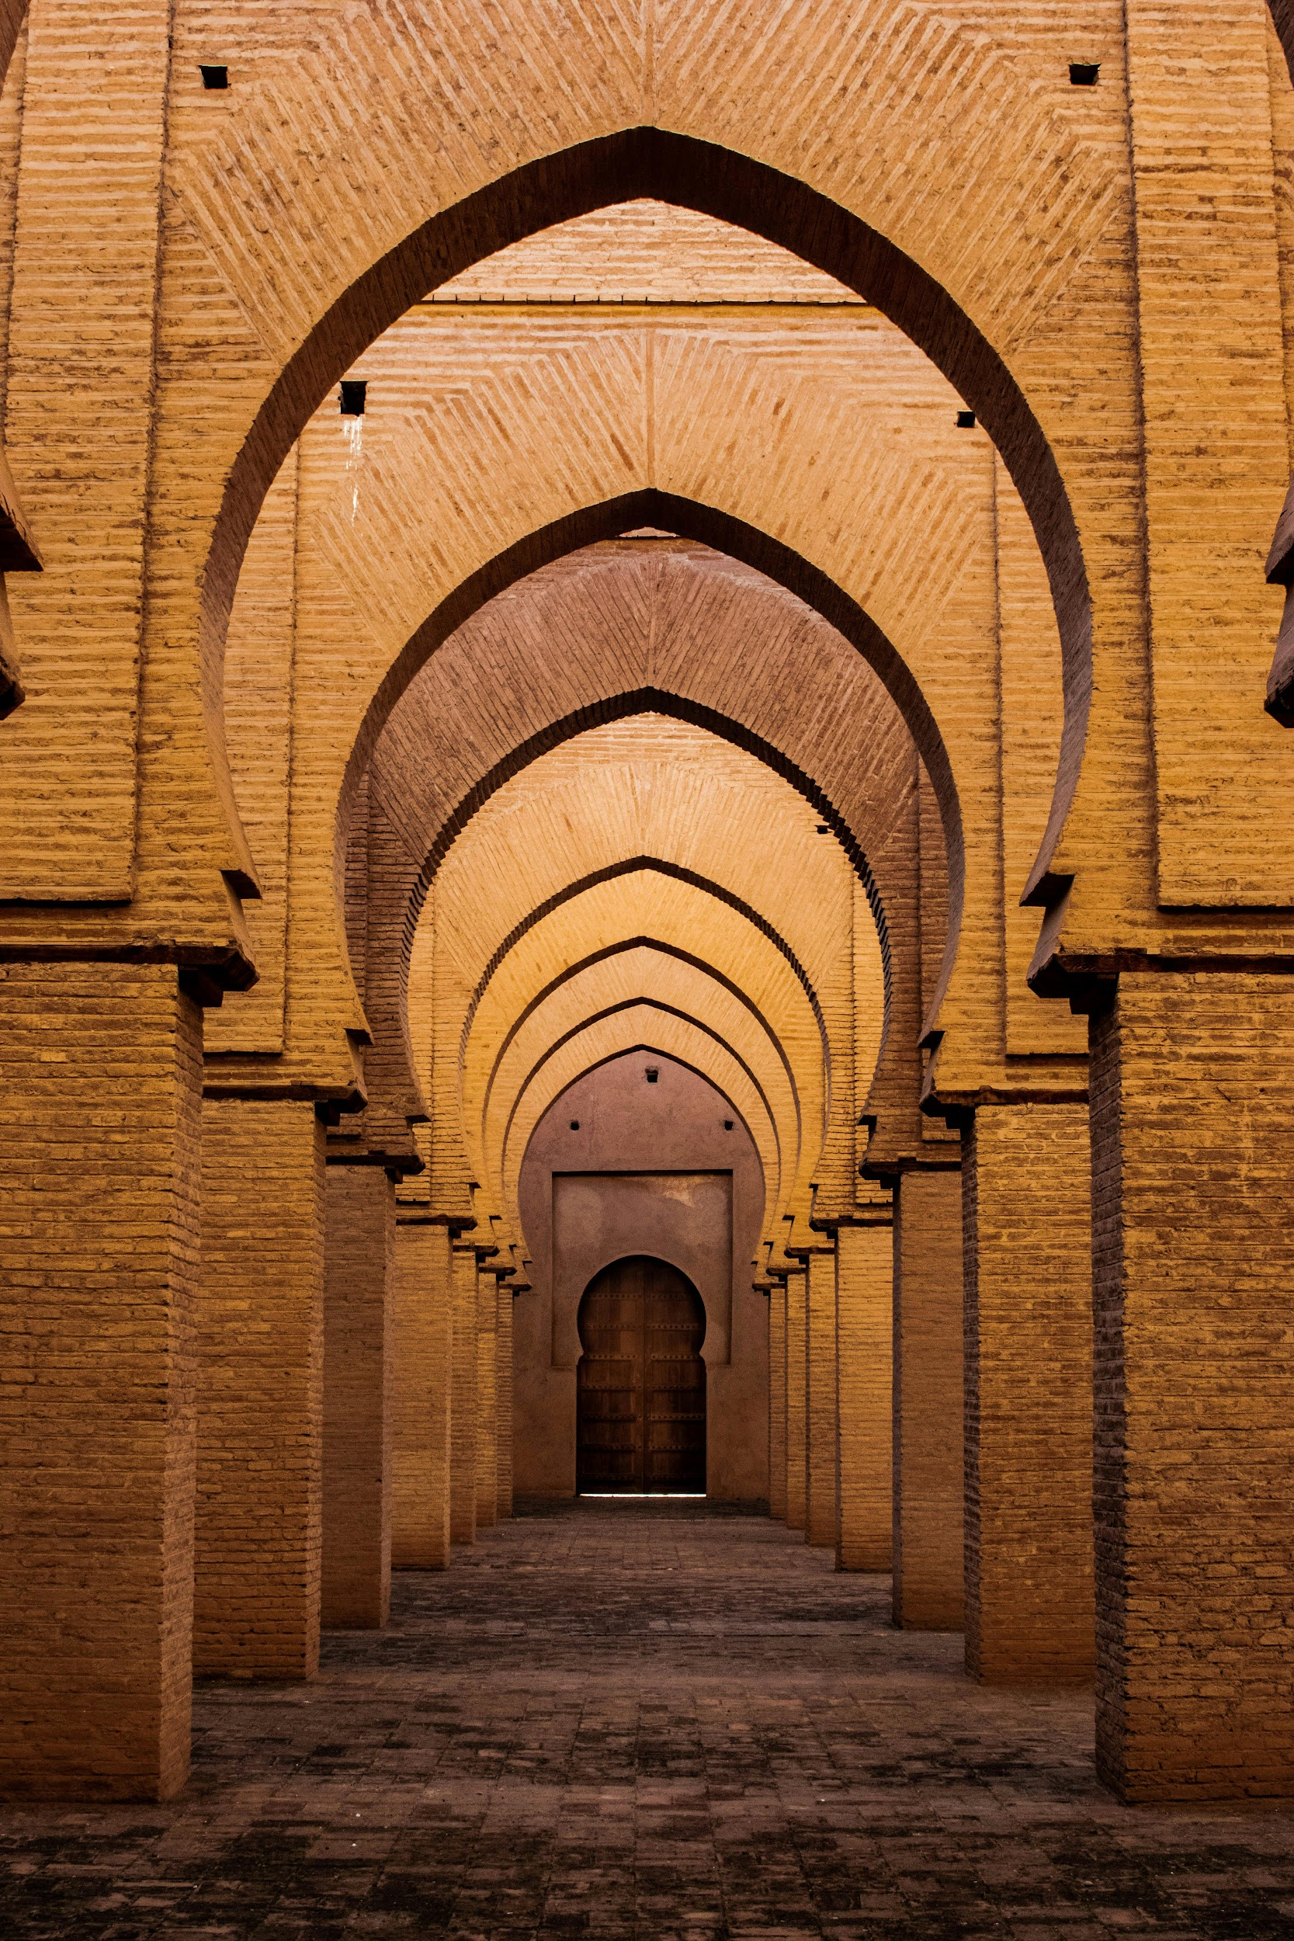

# Contrast

Contrast in interior design highlights differences between elements to create visual interest and dynamism. It involves the juxtaposition of different colours, shapes, textures, or styles (fig 5).

Application in an Interior Design Project:

* **Colour Contrast**: Use contrasting colours, such as black and white or complementary colours like blue and orange, to create a striking visual impact. This technique can be applied in upholstery, wall paint, or accessories.
* **Material** and **Texture Contrast**: Combine materials like metal and wood or textures such as a smooth velvet sofa with a rough-hewn wooden coffee table to add depth and intrigue.
* **Shape** and **Form Contrast**: Mix geometric and organic shapes. For example, place a

circular rug in a room with predominantly linear furniture to introduce a sense of contrast.

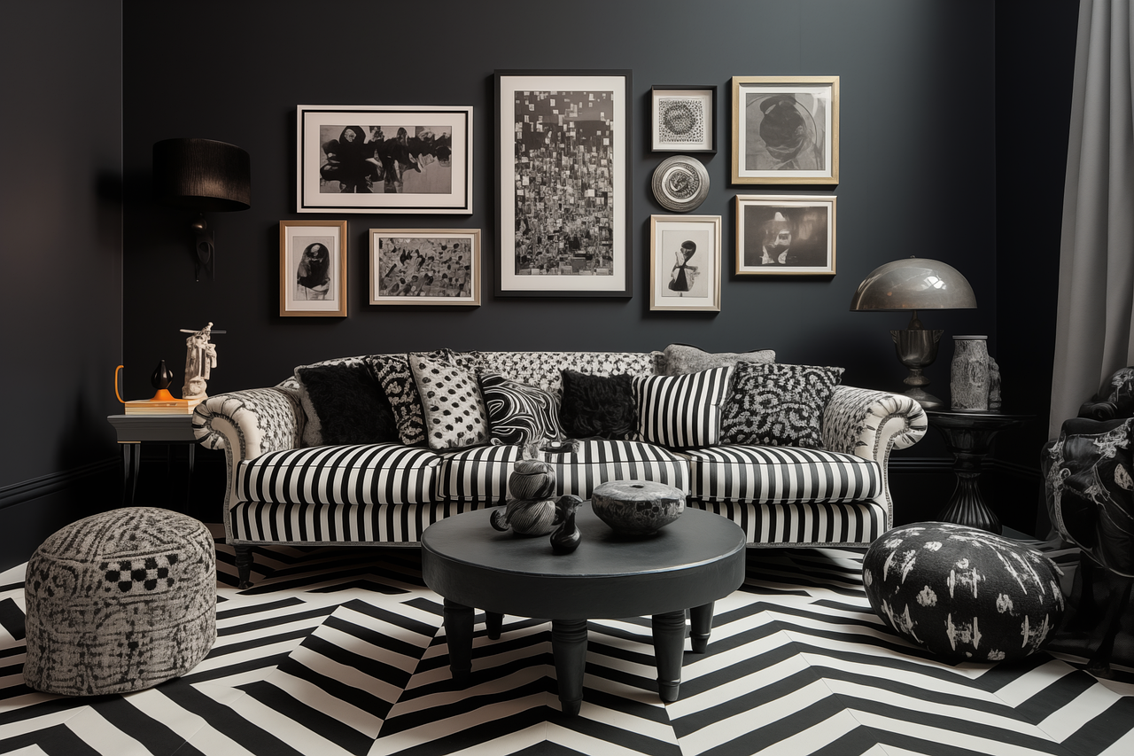

Fig. 4. Pixabay (n.d.), Contrast in shape and colour

# Dominance

Dominance in interior design involves creating a focal point or a standout element that anchors the room. This element draws attention and gives the space a sense of purpose and hierarchy.

Application in an Interior Design Project:

* **Feature Walls:** Paint one wall in a bold colour or cover it with a striking wallpaper to make it the room’s dominant feature.
* **Statement Furniture:** Use a large or uniquely designed piece of furniture, such as an oversized sofa or an intricately carved coffee table, to establish dominance.
* **Artwork and Lighting:** Position a large piece of artwork or an eye-catching light fixture prominently to capture attention and define the room’s character.

# Focal Point

A focal point is the centre of interest in a room, drawing the eye and anchoring the design. It can be an architectural feature, a piece of furniture, or a decorative element.

Application in an Interior Design Project:

* **Fireplaces** and **Windows**: Use existing architectural features like fireplaces or large windows as focal points by arranging furniture to highlight these elements.
* **Accent Walls**: Create a focal point with a feature wall using bold colours, textures, or large- scale artwork (Fig 6).
* **Large Furniture Pieces**: Position a distinctive piece of furniture, such as a grand piano or a unique coffee table, in a prominent spot to serve as the room’s focal point.

Fig. 6. AI Generated (n.d.), Focal Point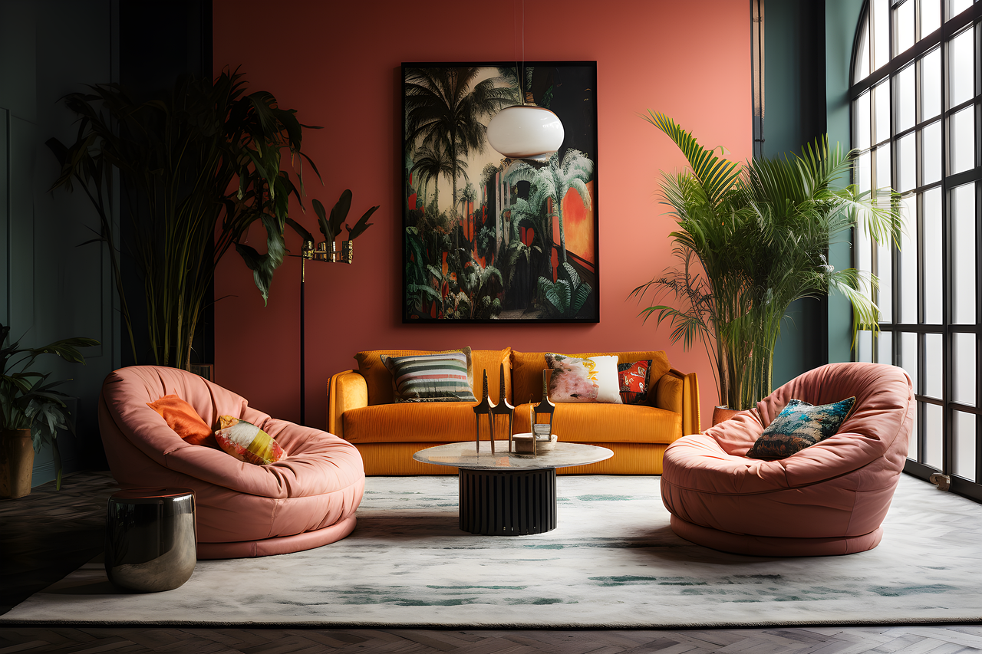

# Scale

Scale refers to the size of objects in relation to the space they occupy and to each other. Proper scaling ensures that a room feels balanced and comfortable.

Application in an Interior Design Project:

* **Appropriate Furniture Sizes**: Choose furniture that fits the scale of the room. Large, open spaces can accommodate bigger pieces, while smaller rooms require more compact furniture. 
* **Scaling Decorative Elements**: Use decor items that are proportional to the furniture and the room’s size. For example, a large room can handle an oversized piece of art, while a smaller space benefits from more modest-sized decor.

# Proportion

Proportion is the relationship between the sizes of different elements within a space. It ensures that no single element overwhelms the others.

Application in an Interior Design Project:

* **Furniture Groupings**: Arrange furniture in groupings that are proportional to the space. For example, a large sectional sofa should be paired with a proportionally sized coffee table and rug.
* **Proportional Decor**: Select decor items that complement the size of the furniture and room. A tall floor lamp works well with a high ceiling, while a smaller lamp fits better in a low-ceilinged space.